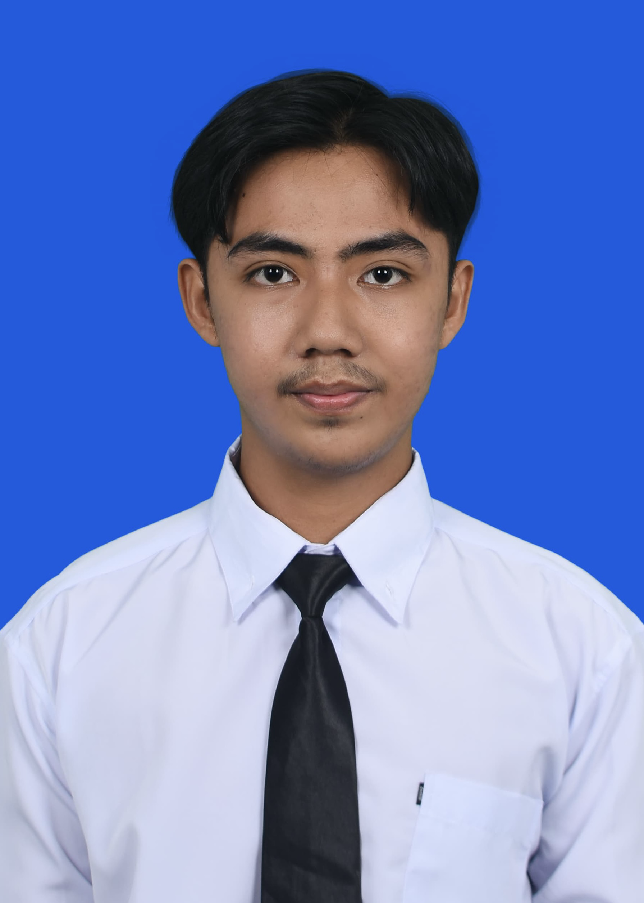
MUHAMMAD FATHONI
Address: Jakarta, Indonesia
Phone: +6282258503481
Email: fathonimuhammad2411@gmail.com
LinkedIn: linkedin.com/in/muhammad-fathoni-038274266

PERSONAL PROFILE

Electrical Engineering graduate of Universitas Islam Indonesia (May 2026, GPA 3.78/4.00) bridging hardware engineering with modern software and AI. Work spans electrical systems, embedded controllers, and IoT alongside mobile development, LLM integration, and N8N automation. Built and launched Noora at Noora Deen Technology as the engineer (cross-platform Android and iOS). Strong interests in electric vehicles, robotics, and applied AI; a fresh graduate who learns fast, adapts quickly, and performs well under pressure.

CORE EXPERTISE
- Generative AI & LLM Integration: Building systems where language models like Claude and Google Gemini handle real product tasks. Daily use of AI as a pair programmer for design decisions and debugging.
- Full stack Mobile Engineering: Android and iOS development with Capacitor 8. Shipped Noora, an Islamic lifestyle app, with everything from UI to release pipeline handled in-house.
- Backend & Cloud Architecture: Comfortable working with Supabase, Firebase, and REST APIs. Designed multi-device sync that holds up even when users switch phones mid-session.
- Electrical Engineering & EV Systems: Electrical wiring, troubleshooting, and Proteus simulation. PID control on LabVIEW, VHDL/Quartus FPGA programming, plus hands-on EV electrical work and robotics wiring.
- Workflow Automation: Building N8N workflows for chatbot integrations, scheduled reports, and anomaly alerts. Applied in SEMS for Telegram bots, daily energy reports, and electrical anomaly notifications.
- Machine Learning & IoT: Built a smart energy monitoring system using ESP32 sensors and a Random Forest model with Google Gemini layered on top for personalized tips.

PROFESSIONAL SKILLS
- Programming Languages: JavaScript, Python, SQL (PostgreSQL), C, C++, HTML, CSS, VHDL
- AI & Automation: Claude and Google Gemini integration, prompt engineering, N8N workflow automation, scikit-learn, Random Forest
- Frontend & Mobile: Vanilla JavaScript, Capacitor, Android and iOS development, Web APIs for geolocation and notifications, responsive UI
- Backend & Cloud: Supabase (Auth, Postgres, Realtime, Row-Level Security), Firebase, REST APIs, Flask, Heroku, Cloudflare R2
- Electrical & Hardware: Proteus, LabVIEW, Quartus, FPGA implementation, PID control, ESP32 embedded development, electrical wiring and troubleshooting, EV and robotics electrical systems
- Tools & DevOps: Git, GitHub, Node.js, Android Studio, Google Colab, Microsoft Office, Antigravity
- Interpersonal: Fast learner, adaptive under pressure, project management, end-to-end product ownership, teamwork, analytical thinking, leadership, problem-solving
- Spoken Languages: Indonesian, English

EDUCATIONAL HISTORY

Universitas Islam Indonesia, Yogyakarta August 2022 – May 2026
Undergraduate in Electrical Engineering, GPA: 3.78/4.00

WORK EXPERIENCES

NOORA DEEN TECHNOLOGY
Part time – Full stack / AI Engineer May 2026 – Present
- Develop Noora, an Android app made with Capacitor. It includes location-based prayer times, the full 30-juz Quran with Kemenag translation and per-ayah audio, daily hadith, a digital tasbih, sunnah fasting reminders based on the Hijri calendar, and a streak system that keeps users consistent.
- Handled the whole technical stack: an offline-first frontend using vanilla JavaScript and LocalStorage, a Supabase backend with authentication, database, realtime sync, and row-level security, plus the native packaging and release pipeline for both Android and iOS. I used Claude as my pair programmer throughout for design decisions and debugging.

PT PLN (PERSERO) ULP PASIR PENGARAIAN
Internship – Technical Division September 2025 – Oktober 2025
- Used the APKT PLN system to analyze outage data and reliability metrics like SAIDI and SAIFI, helping the technical team make better decisions.
- Documented service interruption cases and put together reliability reports for performance reviews.

UNIVERSITAS ISLAM INDONESIA
Laboratory Assistant February 2024 – January 2026
- Subjects: Electric Circuit II, Telecommunication System, Digital System, and Control System (Feb 2024 – Jan 2026).
- Ran practical sessions covering circuit analysis, signal processing, VHDL programming on Quartus with FPGA, and PID control on LabVIEW (air heater and DC motor setups).
- Built up teaching and communication skills while helping students work through tough engineering concepts.

ORGANIZATIONAL EXPERIENCES

IEEE Student Branch Universitas Islam Indonesia, Yogyakarta
Director of Academies June 2024 – May 2026
- Lead the planning and rollout of academic programs that help members grow technically and professionally.
- Handle strategic planning, lead the team, and run initiatives that expand the organization’s impact.

Ulil Albab Student Center Electric Vehicle, Yogyakarta
Head of Programming / Electrical Engineer July 2023 – Maret 2025
- Led the programming and electrical systems team for vehicle control, keeping execution aligned with technical and performance goals.
- Designed and troubleshot EV electrical wiring and used Proteus for circuit simulation to optimize system performance and safety.

Unisi Robotic
Electrical Division Staff May 2024 – May 2026
- Design and build electrical wiring systems for robotic projects.
- Diagnose and fix electrical issues to improve system reliability.

ACHIEVEMENTS

- 3rd Place PKM IC Community Service Scheme (2025)
- 1st Place in IT Centrum Startup Hackathon 2024 at Universitas Islam Indonesia (December 13 – 14, 2024)
- 1st Place in Business Idea Competition, part of the Entrepreneur Competition during Student Entrepreneur Day 2024

PROJECTS

Noora: Cross-platform Islamic Lifestyle Mobile App (May 2026 – Present)
- Mobile app for Android and iOS built with Capacitor 8, made for Indonesian Muslims. Features prayer schedules, the full Quran with Kemenag translation, daily hadith, a digital tasbih, and sunnah fasting reminders that follow the Hijri calendar.
- Designed a multi-device sync system on Supabase Postgres and Realtime that works offline and handles conflicts cleanly. Also built a streak system with a “Freeze Token” mechanic that keeps users coming back every day.

SEMS: Smart Energy Management System based on IoT, Machine Learning Prediction, and AI-Powered Recommendations (September 2025 – May 2026)
- IoT-based energy monitor for Indonesian homes, using ESP32, PZEM-004T, and DHT22 sensors paired with a responsive web dashboard backed by Firebase.
- Trained a Random Forest model that predicts monthly consumption, then deployed it as a Flask REST API on Heroku.
- Google Gemini 2.5 Flash gives users energy-saving tips by PLN tariff bracket (450VA to 5500VA). Buzzer alerts trigger on detected anomalies, and N8N automates Telegram chatbots, daily reports, and electrical anomaly notifications.

AromatheraWrist: Smart Bracelet Innovation Integrated with Aromatherapy and Pulse Sensor that Can Be Controlled Via Application as an Alternative for Overcoming Anxiety (January 2024 – August 2024)
- Smart bracelet that combines a real-time pulse sensor with aromatherapy to help reduce anxiety, paired with a mobile app for stress tracking and aromatherapy triggers.
- Received funding from Indonesia’s Student Creativity Program (PKM-KC) 2024.

TRAINING, LICENSES, AND CERTIFICATIONS

Department of Electrical Engineering Universitas Islam Indonesia November 11, 2024 and Mei 17, 2025
Python Class for Data Scientist (Beginner)

Department of Electrical Engineering Universitas Islam Indonesia December 21, 2024
Basic PLC Training

Huawei Talent Online December 13, 2023
HCIA-Datacom V1.0 Course

